Not Doom (working title)
21/02/2020

Designer: Julien Lubimiv

Table of contents

Overview................................................................................................................. 3-4
Location & Environment............................................................................. 3
Level Assets................................................................................................ 3-4
Level Difficulty........................................................................................... 4
Map Layout............................................................................................................. 5-7
Map Description...................................................................................................... 7-9
Pacing Chart............................................................................................................ 9

Overview

Level Location and Environment

Environment: Mars
- Red surface
- Rocky terrain
- Very dusty

Location: Mars Processing Facility
- A mix between clean sci-fi and industrial themes
- Some demonic corruption to the overall environment
- Located in a mars crater

Story
You are a prisoner from Earth sentenced to forced labor on Mars. Shortly after arriving in your cell, something in the facility panicked the employees. Unable to tell what is going on from your cell, the player will hear all sorts of terrible noises until there is a calm. The doors to your cell open to reveal hell has taken over and you need to fight your way off the “doomed” planet.

Level Assets

Props
- Traffic cone
- Assorted Sci-fi boxes and crates
- Explosive barrels
- Gas cables
- Handgun
- Shotgun
- Rifle
- Rocket Launcher
- Janitorial supplies
- Heavy Machinery Parts
- Ladders
- Forklift
- Sci-fi tables
- Sci-fi Desks
- Rocks
- Sci-fi Consoles
- Ventilation Grate

Power-ups / Collectibles
- Berserker
- Superfast
- Invulnerable

Enemies
- Zombie
- Zombie w/ gun
- Imp
- Flying Skull
- Reaper
Other NPCs:
- Facility AI

Level Difficulty

The Level design for this game is broken down into two parts:

Arenas:
- Focuses on the main game loop in a contained area that encourages players to move and play aggressive.
- Player Progresses after killing waves of enemies.
- Few hazards but lots of enemies!

*Maps are provided for these

Transitions:
- Focuses on the secondary game loop (exploration/secrets) while leading to the next arena.
- Player Progresses through hazards and platforming with little fighting in between.
- Keen players might find new weapons early, alternate arena entrances with powerups, and useful collectables.

*Maps not provided yet. I need to see what everything looks like together to get a good idea how everything fits.

Arena Map Layout

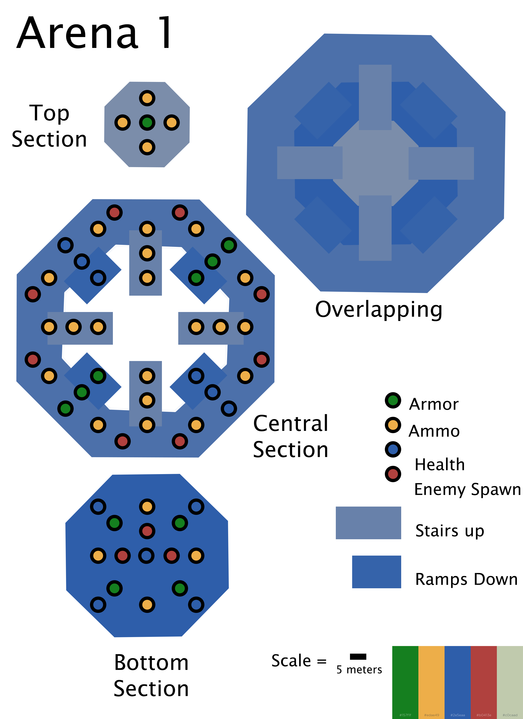
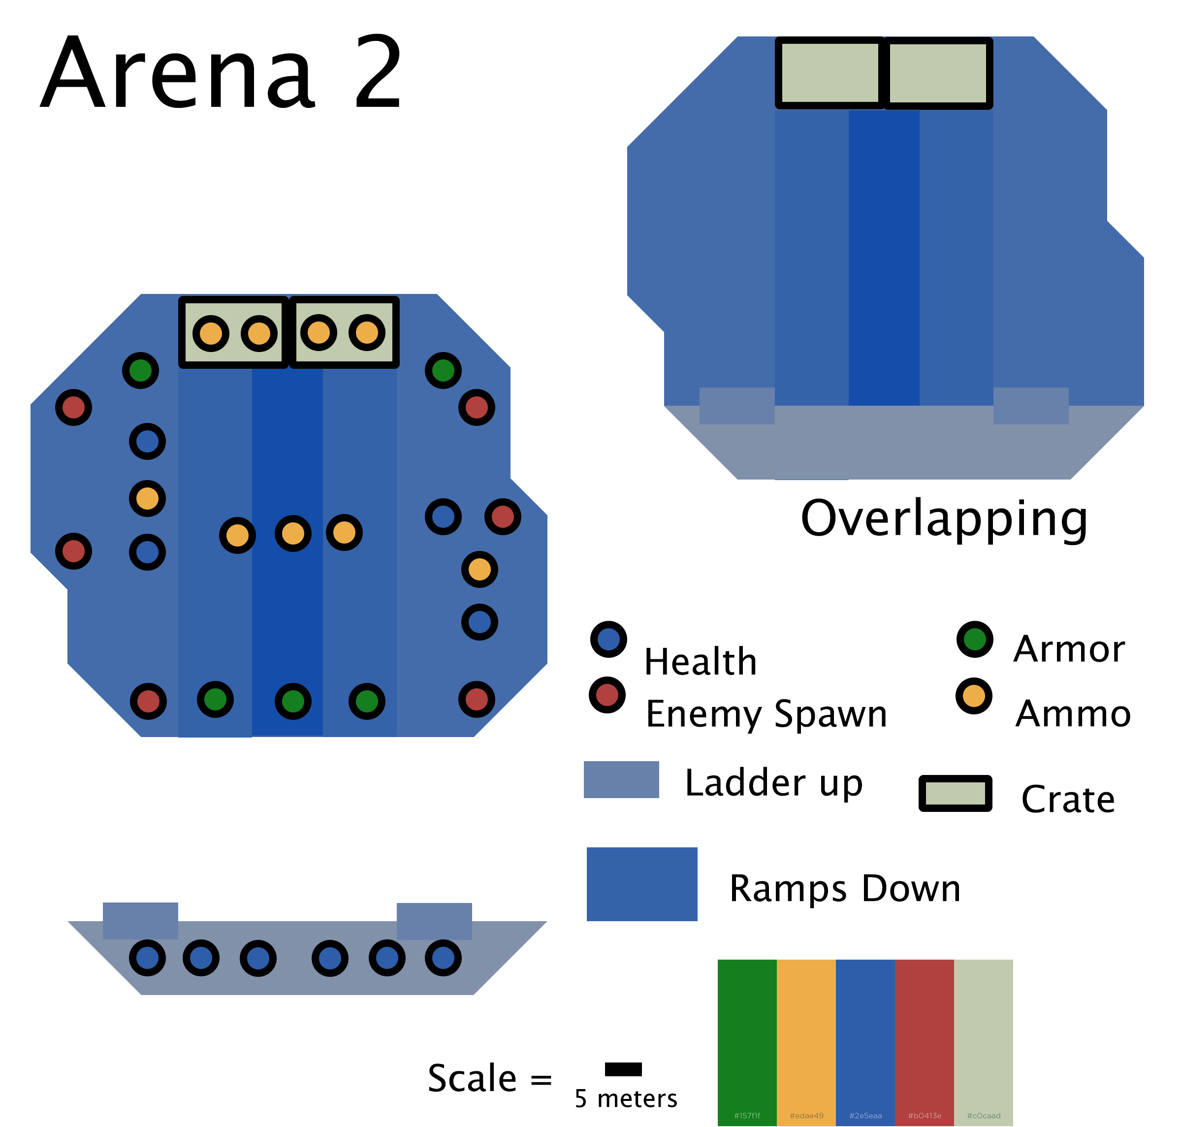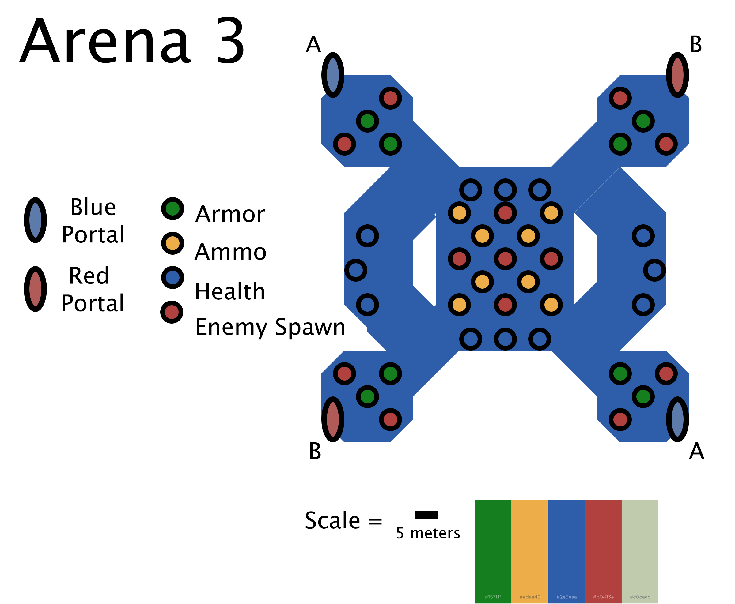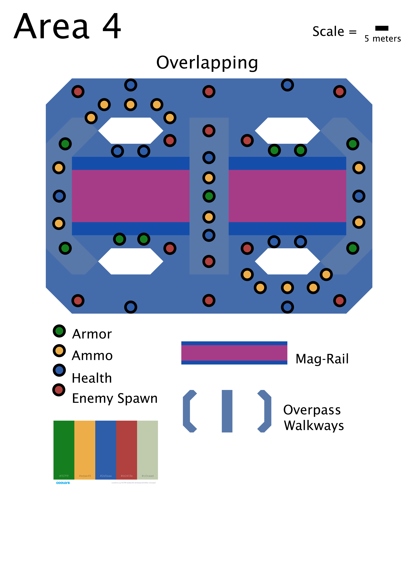

Map Description

Please view Arenas 1-4 for better view of level layout.

Arena 1

- Basic Symmetrical shape
- Plenty of ammo to try out weapons
- Enforces aggressive play to condition the player to move
- Paths created with collectables rewards variation.
- Difficulty: Pretty easy but enjoyable and informative

Arena 2

- Smaller asymmetrical shape
- Emphasizes environmental play
- Branching paths when completed
- Lava Hazard in the trench deals damage when contacted
- Difficulty: Somewhat challenging. Introduces hazards in arenas.

Arena 3

- Focus on path variation in order to keep up with collectable economy.
- Portals allow more options for paths to take while moving.
- Difficulty: Moderately Challenging

Arena 4

- Large area with crates to weave between or over.
- Many enemies will spawn.
- Boss enemies will spawn.
- Rail Hazard will deal damage when in contact.
- Difficulty: Challenging

Pacing Chart
